Created on: 4/27/05
Topic: AGNs and Galaxy Evolution & Dark Matter and the Large-Scale Structure of the Universe

- Next rungs on the cosmological distance ladder:
  - The Tully-Fischer Relation
    - To measure the distance to a spiral galaxy:
      - Measure the red shifts and blue shifts
      - Calculate the speed the stars are orbiting the center of the galaxy
      - Calculate the gravitational force acting on the stars
      - Calculate the mass of the stars
      - Take a 10th of the mass because 90% of the mass of the galaxy is made of dark matter
      - Find the luminosity and combine it with the apparent magnitude to finally get the distance
    - Relating the rotation curve of the galaxy and the luminosity of the galaxy
    - The faster the rotation curve, the brighter the galaxy
    - Works out to 10 mega parsecs (10,000,000 parsecs)
    - Does not work for elliptical galaxies
    - If you find a spiral galaxy within a cluster of elliptical galaxies, you can still find the distance to the spiral which finds the distance to the other elliptical galaxies.
  - The Type 1a Supernova Method
    - Normal supernova are Type II supernova
    - Type Ia happen due to material surrounding a white dwarf (the accretion disc) falling into it, which makes it more massive
    - When the white dwarf reaches 1.44 solar masses the electron degeneracy pressure cannot support the star anymore and it explodes
    - More powerful and brighter than a type II supernova
    - We figure out what kind of supernova (type Ia or II) but figuring out the light curve
    - Light curve – Amount of light as a function of time
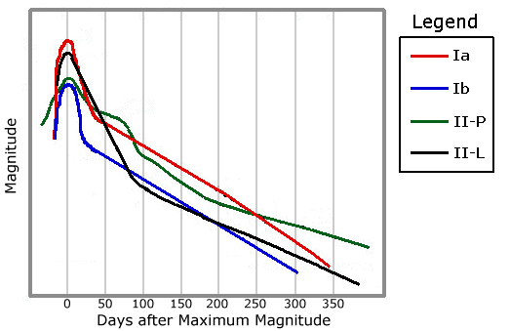
← Type Ia

← Type II

    - Standard candle – Something with a fixed known brightness (like the type Ia supernova)
    - You can see these across the observable Universe!!
    - Works out to 100 mega parsecs (100,000,000 parsecs)
- Groups and Clusters
  - Groups of galaxies have up to 5 major galaxies in them (a few dozen galaxies total)
  - Clusters of galaxies have up to hundreds of major galaxies in them
    - In the center of clusters are giant elliptical galaxies
    - Around the giant elliptical galaxy, there are smaller elliptical galaxies
    - At the outskirts of clusters there are spiral galaxies
  - The Milky Way galaxy is in a group known as “the local group”
- Dark Matter
  - Clusters are filled with diffuse gas (75% hydrogen, 25% helium) known as Intergalactic Medium (aka Intra-Cluster Medium)
    - Gas that fills this stuff is millions of kelvins (very hot) but very diffuse
    - Turns out 90% of this gas fills the cluster, so it must be dark matter
  - Interstellar Medium (aka Intra-Galactic Medium)
- AGNs (Active Galactic Nuclei)
  - Most other galaxies in the Universe have huge luminosities and radiate a lot of energy and x-rays
  - Most of this energy is coming from the nucleus of the galaxy (known as AGNs, see title)
  - Quasar – Quasi-stellar objects. Type of AGN.
  - A super massive black hole (a billion solar masses) surrounded by a huge accretion disc (size of the Solar System) powers AGNS/Quasars
  - The reason why most other galaxies in the Universe are radiating a lot of energy is because all galaxies are born with giant quasars and AGNs, and we are only seeing them now because of how far away the other galaxies are. They are probably normal galaxies right now
- Parts of the Universe
  - The Great Wall – Organization of super clusters
  - The Great Attractor – Organization of super clusters that is attracting our super cluster (the Virgo super cluster)
  - The Great Void – Huge empty spaces in the Universe
  - At the largest scale, the Universe is homogeneous
- Gamma Ray Bursts
  - Coming from outer space every day
  - The gamma ray bursts are coming from explosions in the Universe at most billions of light years away
  - These explosions are the most powerful explosions in the Universe
  - These explosions come from exploding black holes due to hawking radiation (below)
- Hawking Radiation
  - Hawking came up with the theory of thermodynamics of black holes (aka he found out that stuff radiates from black holes)
  - Hawking temperature – Temperature of a black hole
  - Virtual particles – A vacuum creates particles which then disappear so fast that no one has a chance to notice
  - Virtual particles have been proven because when they are alive they do things (such as interacting with electrons)
  - Casimir Effect – Virtual particles make things attract each other more than they normally should
  - Hawking radiation – Black holes become smaller and a stream of particles are coming from (not OUT OF) the black hole
  - When a black hole gets smaller, it gets brighter
  - If it gets small enough, it’ll get right enough and explode
- Black holes
  - 3 kinds in our Universe:
    - 1.) Normal black hole (stellar mass black hole) that comes from the death of a high mass star (3 solar masses)
    - 2.) Super massive black hole (up to a billion solar masses) at the center of every galaxy
    - 3.) Microscopic black holes. Event horizons are a bit smaller than the nucleus of an atom. Born in the early Universe. Causing Hawking Radiation? (Not proven to exist)

